|  |  |
| --- | --- |
|  | **Year 11 ATAR Human Biology**  **Task 1 – The exchange of materials** |

|  |  |  |  |
| --- | --- | --- | --- |
| **Name:** | **Teacher:** | **Date:** | **Score:**  /30 |

**Assessment type:** Science Inquiry - Practical

**Conditions**

Time for the task:

* Part A: Practical activity (carried out in groups in prior lesson to Part B)
* **Part B: 50 minutes in class validation assessment**

**Task weighting** – 10%

_____________________________________________________________________________________

**Part B:** Validation

To discover how substances move into and out of cells at different temperatures, a student designed an experiment and set up the apparatus shown below:

* The cellulose tubing has similar properties to a cell membrane.
* Starch is a long chain carbohydrate.
* Iodine is in an ionic solution outside the cellulose bag.

She placed one apparatus in a fridge at 4ºC and the other apparatus in a room at 25ºC

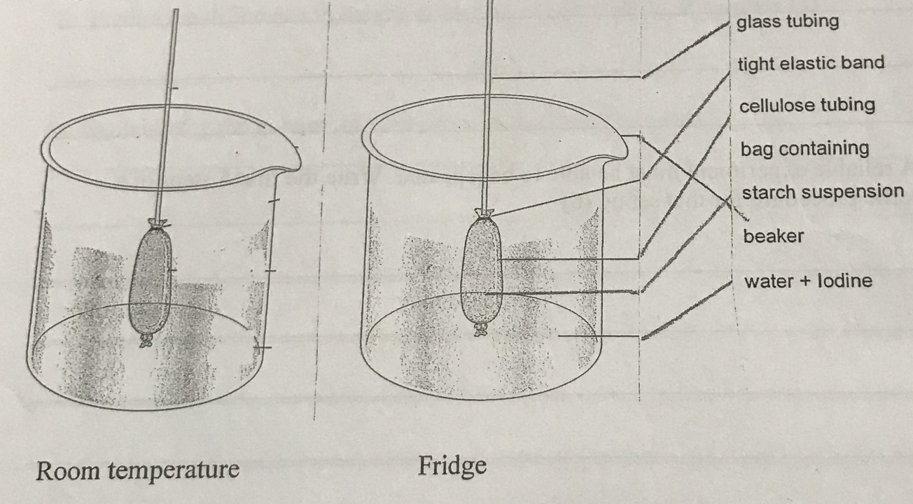

**Results Table:**

Data collected showing the height of the column of water in the capillary tube.

|  |  |  |  |  |  |
| --- | --- | --- | --- | --- | --- |
| **Temperature** | **Height of the column of water in the capillary tube (mm) at time (min)** | | | | |
|  | **0 minutes** | **4 minutes** | **8 minutes** | **12 minutes** | **16 minutes** |
| **Room (25°C)** | 0 | 22.0 | 33.0 | 38.5 | 41 |
| **Fridge (4°C)** | 0 | 12.0 | 18.0 | 21.5 | 22.5 |

1. Graph the data on the graph paper provided. (5 marks)
2. State a hypothesis for the experiment.

____________________________________________________________________________________________________________________________________________________

(2 marks)

1. State the independent variable: _________________________________________________ (1 mark)
2. State the dependent variable: __________________________________________________ (1 mark)
3. List 4 controlled variables:

_____________________________________________

_____________________________________________

_____________________________________________

_____________________________________________

(2 marks)

1. Explain why a controlled experiment is necessary.

____________________________________________________________________________________________________________________________________________________

(2 marks)

1. Explain why the column of water rose in the capillary tube.

________________________________________________________________________________________________________________________________________________________________________________________________________________________

(4 marks)

1. When potassium iodide solution is added to the solution **outside the cellulose bag**, it turns the water yellow but when the iodide ion comes into contact with the starch it turns blue.
2. Explain why the internal contents of the starch bag turned blue/black with regard to the movement of molecules.

_____________________________________________________________________

(2 marks)

1. Explain why the external solution did not turn blue/black.

_____________________________________________________________________

(2 marks)

1. Given that the cellulose is a synthetic membrane. Suggest four ways that the membrane of the synthetic cellulose bag would be different from a real cell membrane.

________________________________________________________________________________________________________________________________________________________________________________________________________________________________________________________________________________________________________________________

(4 marks)

1. List 6 substances that move into or out of a cell.

_____________________________ __________________________________

_____________________________ __________________________________

_____________________________ __________________________________

(3 marks)

1. Predict what would happen if an isolated animal cell were placed in distilled water.

Explain why.

____________________________________________________________________________________ ____________________________________________________________________________________ ____________________________________________________________________________________

(2 marks)

**End of Part B**